SERVICE REPORT

 |  |  |  |  | Date: 16/02/2024
Subject: |  |  | W.O.S No.: | N/A
Troubleshooting of DRUMS internet connection on  Marine Selena |  |  | Ship Name / Site: | MARINE SELENA
 |  |  | Sale's P.I.C / Dept: | MR ROMEL / MACHINERY
 |  |  | Work Place: | ANCHORAGE, SINGAPORE
Engineer's P.I.C | MR ROMEL |  | Date: | 16 FEBRUARY 2023
Team Members: | Equipment Model: | Equipment Mfg. Date: |  | Equipment Serial Nos. |  | Running Hours:
TANAPORN(OJT) | DRUMS Version 1.0

1- PREFACE
- As per remote monitoring, Marine Selena has been offline for a big period. We request ship crew to restart the DRUMS panel on 14 February 2024, but the internet still not yet working.

2- WORK SCOPE
- To carry out the inspection of DRUMS equipment internet connection.
3- DISCUSSION
- On board vessel discussed with C/E, found out the vessel

4 – WORK DONE & OBSERVATION

- Visually inspected the existing 4G Dongle and found that there is no power supply indicator light.
- Ensured that the Dongle protection sticker is in good condition.
- Found that the protection sticker or DRUMS has been removed.
- Removed the dongle from the USB cable and directly connected it to the USB hub, but it still could not power up.
- Removed the dongle from the USB hub and connected it to our engineer's laptop, and found that only the internet light is indicating. Tried to connect a USB drive to the laptop, but the connection was intermittent.
- Tried to reset the Dongle, but the reset failed.
- Checked the data flow by connecting directly to the Raspi module (Rx, Tx, and GND) and found that the data is continuously being collected to the DRUMS SD card.
- Checked the available space on the existing SD card and found that around 30% of the memory has been used.

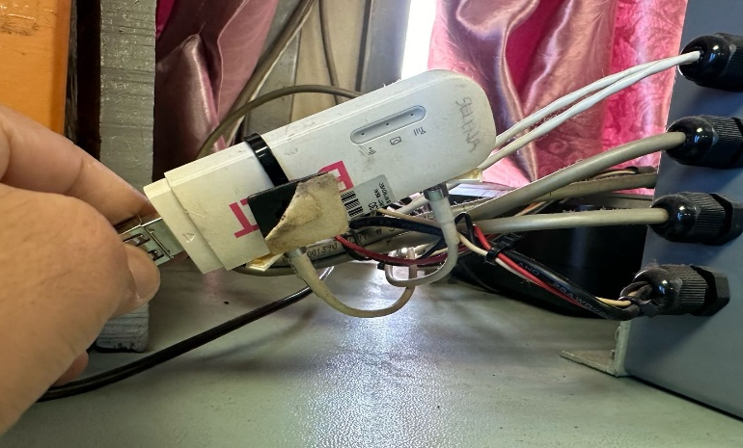 | 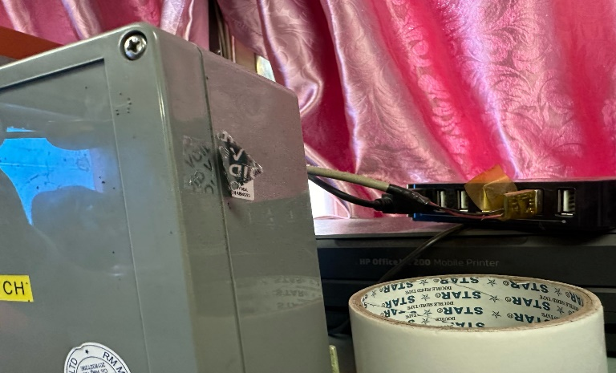
2.4G Dongle’s power light is not indicating.  The protection sticker is in good condition. | DRUMS device protection sticker is damaged
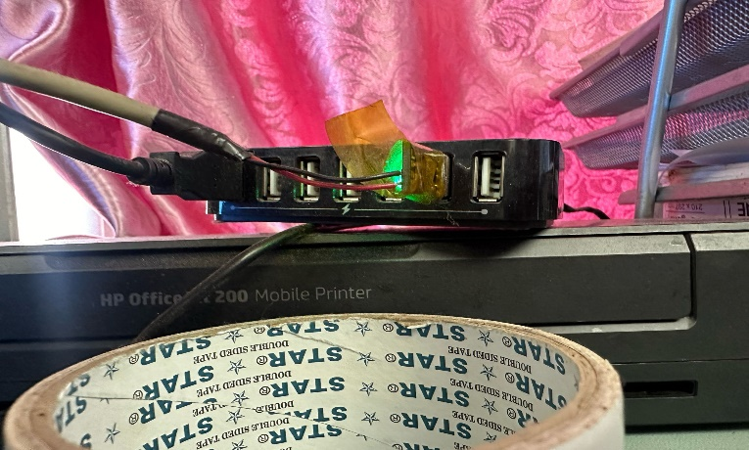 | 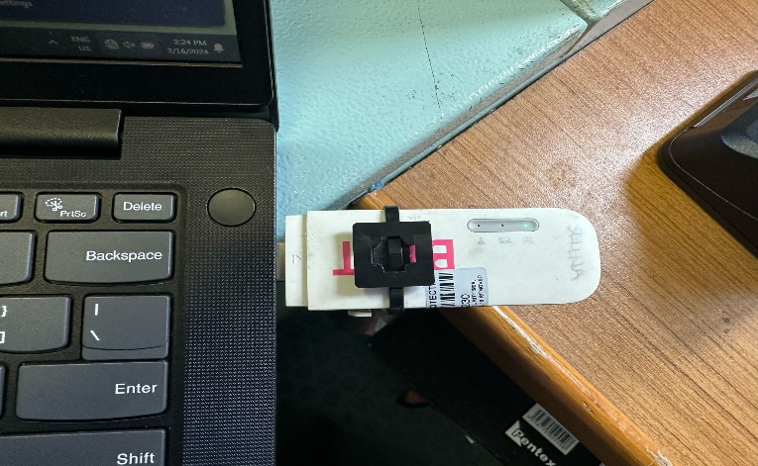
The Data still continue transferring to DRUMS SD card. | Connect Dongle to laptop found out, it continues connect and disconnect and it cannot be reset.

5- RECOMMENDATION

- To replace a new 4G dongle.

PREPARED BY: VERIFIED BY: APPROVED BY:



Tanaporn Mr Romel Mendoza Mr Kuratani Koji

-----END OF REPORT-----

